Another EMERGENCY Call to Prayer NOW
September 2nd, 2020
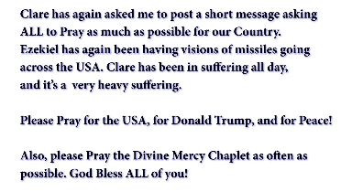
Clare has again asked me to post a short message
asking ALL to Pray as much as possible for our
Country. Ezekiel has again been having visions of missiles going across the USA. Clare has been in suffering all day, and it’s a very heavy suffering.
Please Pray for the USA, for Donald Trump, and for Peace. Also, please Pray the Divine Mercy Chaplet as often as possible. God Bless you!

